**Vim Step by Step Tutorial**

**Step 1:** use thecommand vi [name] to create the file.



**Step 2:** use the command vi [name] to edit the specified file using Vim.

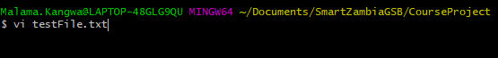

**Step 3**: Immediately after the Vim editor should open automatically. Press the ‘i’ on your keyboard to begin the editing.

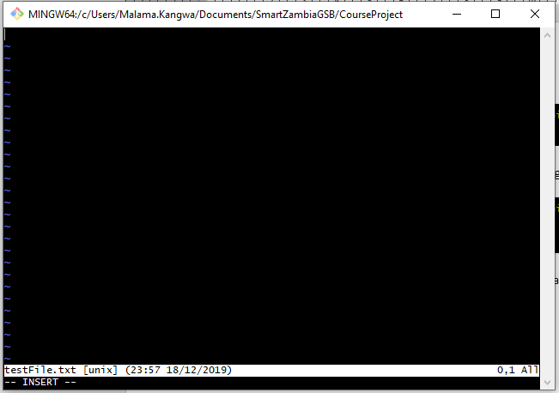  
*the –INSERT—at the bottom shows it is in insert mode and can now be edited.

**Step 4:** Once you’ve typed what you need to, press the ‘esc’ button on your keyboard to exit the insert mode.

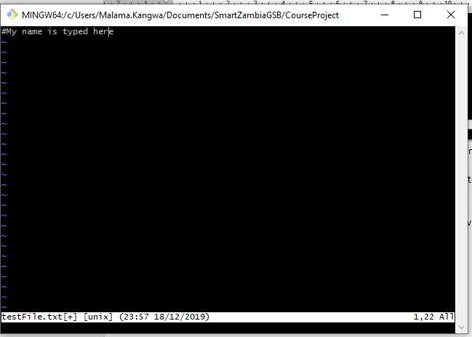

**Step 5**: In order to save your work use the write w command and exit the editor using quit q command.

*Note: After escaping insert mode, the commands must be preceded by a semicolon.

